**URBANA VOLUNTEER FIRE AND RESCUE**

**SPORTSMAN’S RAFFLE**



SATURDAY OCTOBER 8, 2016

Doors Open 4:00pm

Cost: $35.00, a couple

**Reservation Deadline is October 1, 2016**

Make checks payable to: UVFD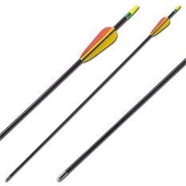

Mail to: **UVFD**

**C/o Ron Wilt**

**3602 Urbana Pike**

**Frederick MD 21704**

Contact: (301) 606-3008 for additional information